EARTH SCIENCE SPECIAL FEATURE
The Shaking Earth: Causes of Earthquakes

The ground under our feet feels very solid. However, the outer layer of the Earth is actually broken into huge pieces. This outer layer is called the crust. The huge pieces are called tectonic plates. They are like giant puzzle pieces that make up the Earth's shell. Tectonic plates float very slowly on hot, melted rock deep inside the Earth. They move only a few centimetres every year.
As these plates float, they move in three main ways. First, some plates pull away from each other. Second, some plates bump into each other. This bumping can push the land up to make big mountains. Third, some plates slide sideways past each other. The places where the plates meet are called boundary zones.
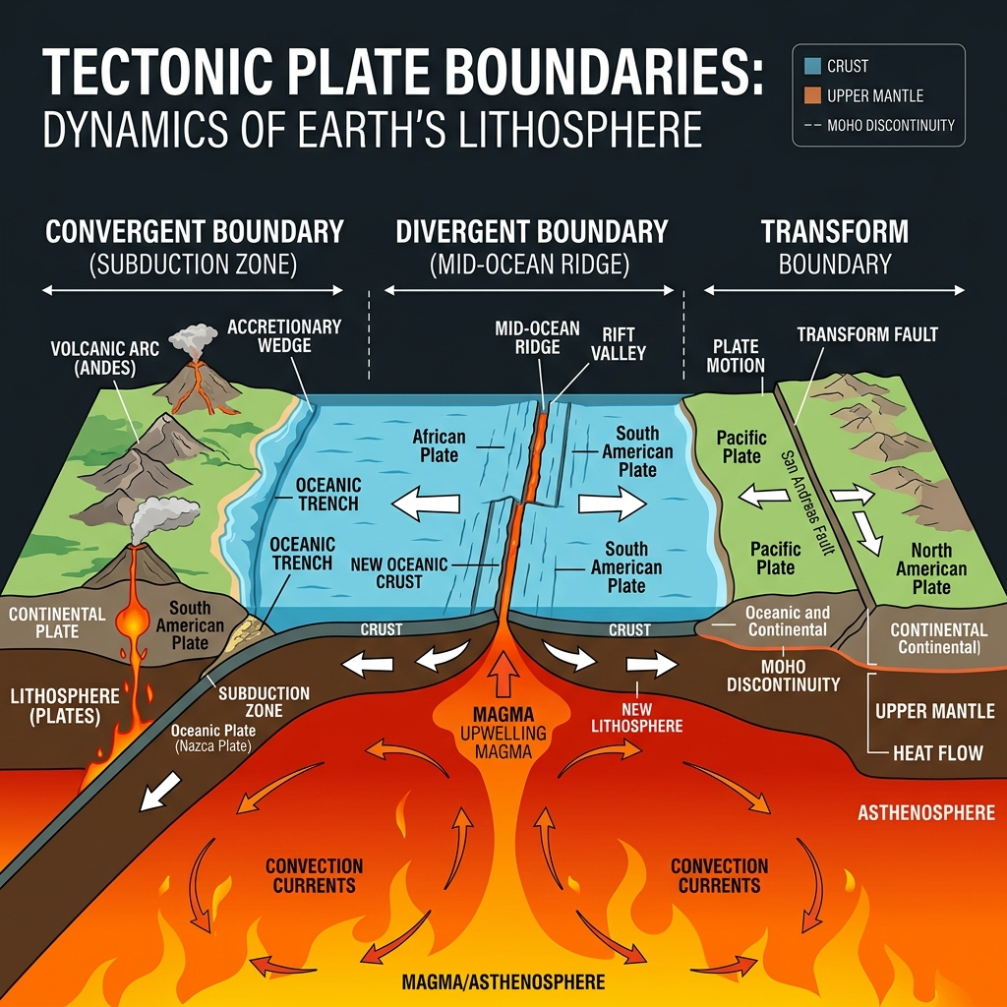
Tectonic Dynamics: Tectonic plates floating on a softer, molten rock layer beneath Earth's outer crust. Arrows indicate the different ways plates interact: pulling apart, pushing together, or sliding sideways.
Tectonic plates have rough and jagged edges. As the plates try to move, their rough edges can get stuck. They stick because of friction. Friction is a force that stops things from sliding easily. Even though the edges are stuck, the rest of the plates keep moving. This creates tension. Tension is growing pressure stored in the stuck rocks.
"Even though the edges are stuck, the rest of the plates keep moving... This creates tension."
— TECTONIC MECHANICS

Over time, this pressure becomes too big. The rocks suddenly break or slip. This slip usually happens along a fault. A fault is a crack in the Earth's crust where rocks can move. When the rocks slip, they quickly release a lot of stored energy.
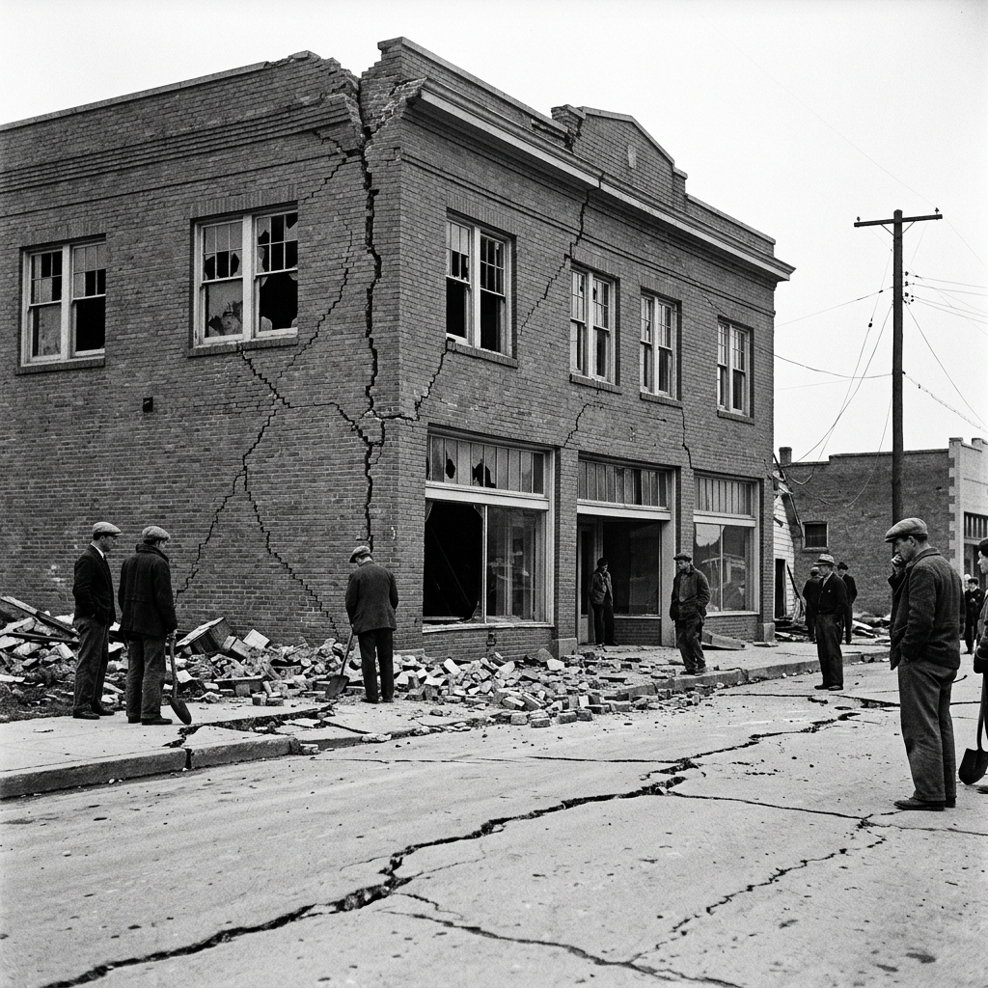
Energy Released: The aftermath of a historical earthquake, demonstrating how massive amounts of stored tension can fracture solid brickwork and split paved roads along active fault lines.
This energy travels out in all directions. It moves as seismic waves. Seismic waves are powerful ripples of energy that travel through the ground. These waves make the ground shake. We feel this shaking as an earthquake. The point deep underground where the rocks first broke is called the focus. The point on the surface directly above the focus is called the epicentre. The shaking is always strongest near the epicentre. Smaller shakes called aftershocks can happen for days or weeks after the main earthquake.
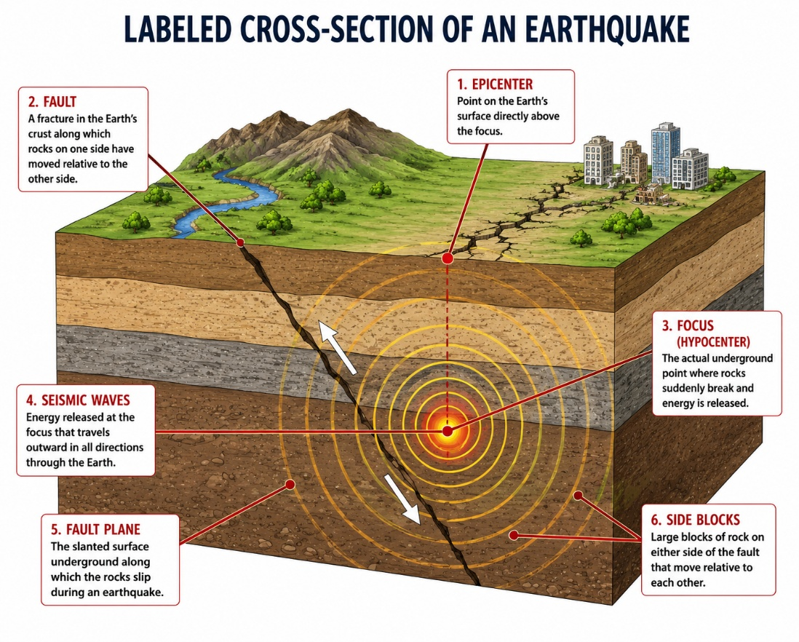
Figure 1 - Earthquake Cross-Section: A cross-sectional view of an active earthquake zone, highlighting the focal point underground, the surface epicentre, and the propagating circular energy waves.
Scientists measure earthquakes with a seismograph. A seismograph is a special machine that measures ground movements. By studying earthquakes, scientists learn how to build safer houses to protect people.
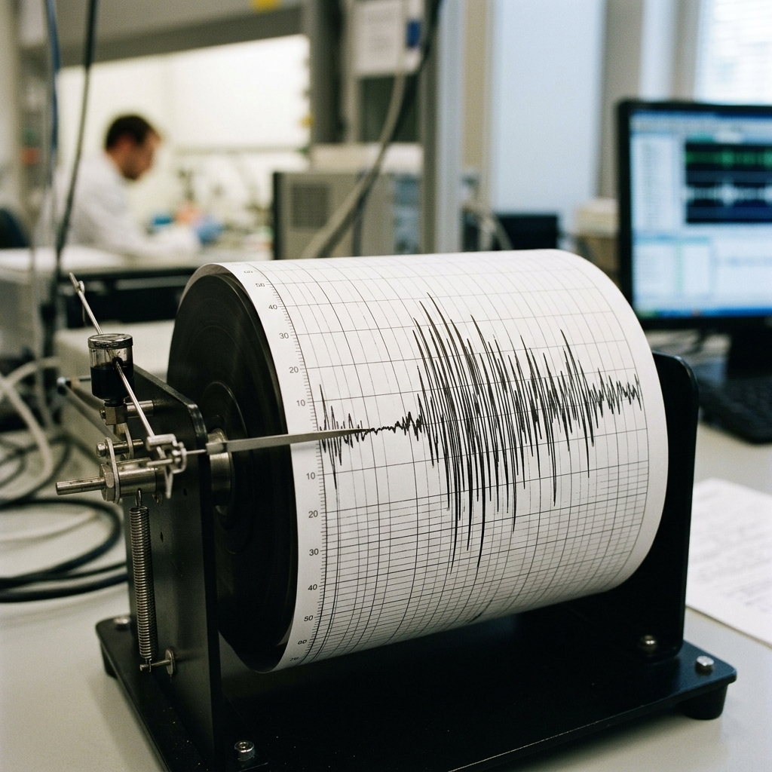
Measuring Shaking: A close-up of a seismograph machine translating raw seismic energy waves into measurable line ripples on paper.
KEY TERMINOLOGY
Epicentre: The spot on the ground directly above where the earthquake starts.
Fault Line: A crack in the Earth's crust where rocks can slip and move.
Focus: The deep spot underground where the rocks first break and move.
Seismic Waves: Ripples of energy that travel through the ground and make it shake.
Seismograph: A special machine that measures how much the ground shakes.
Tectonic: Having to do with the Earth's crust and how its large pieces move.
Tectonic Plate: A giant puzzle piece made of rock that forms the Earth's outer shell.
Tension: Pressure that builds up when rocks are stuck and trying to move.

Plate Boundary Types (Field Comparison Table)

Boundary Type | Direction of Movement | Geological Features Produced
Convergent Boundary | Plates push together | Big mountains, deep ocean trenches, and strong earthquakes
Divergent Boundary | Plates pull apart | Deep valleys, active volcanoes, and small earthquakes
Transform Boundary | Plates slide past each other | Cracks in the ground (faults) and damaging earthquakes

